**ASSIGNMENT-2**

**Q-1 WAVE FORM TRAVERSAL**

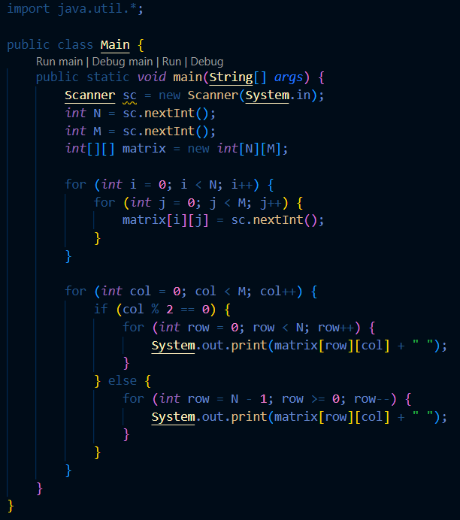

**Output-**

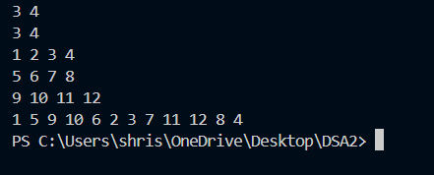

**Q-2 TRANSPOSE OF A MATRIX**

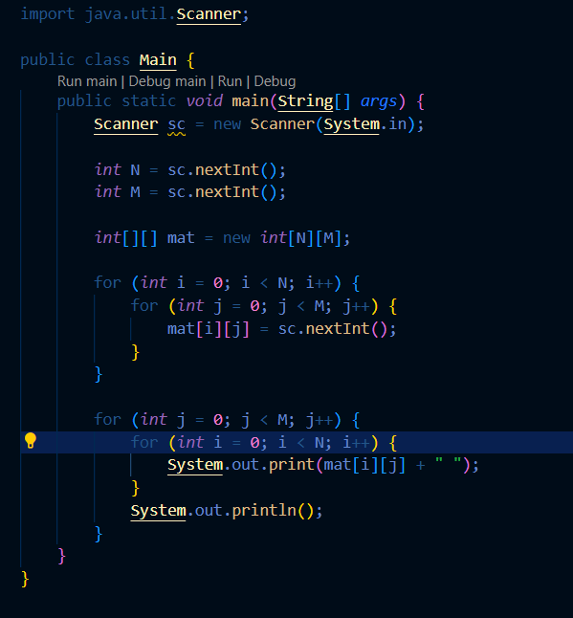

**Output-**

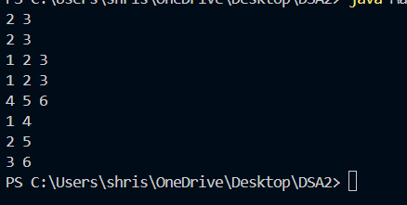

**Q-3 SPIRAL TRAVERSAL OF A MATRIX**

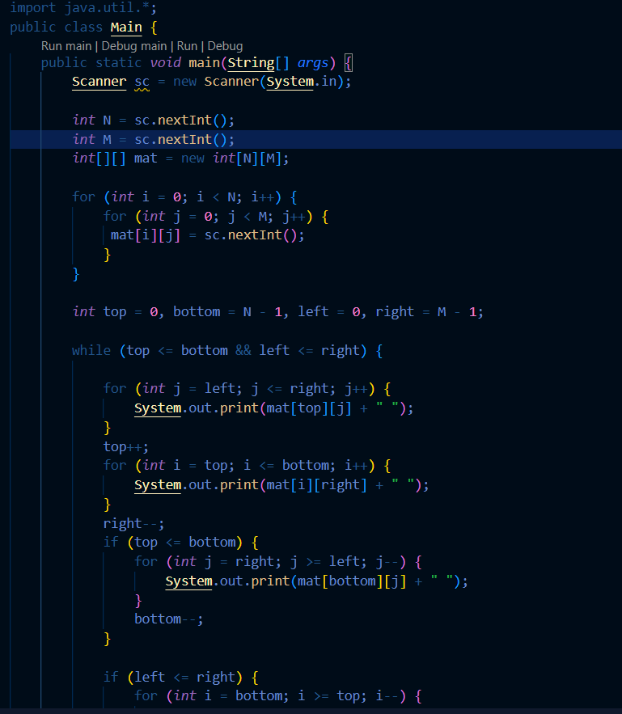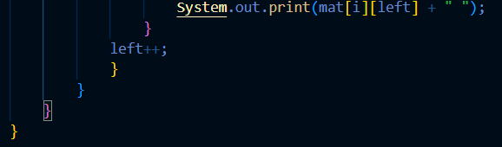

**Output-**

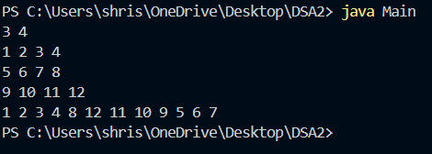

**Q-4 ROTATE MATRIX BY 90°CLOCKWISE**

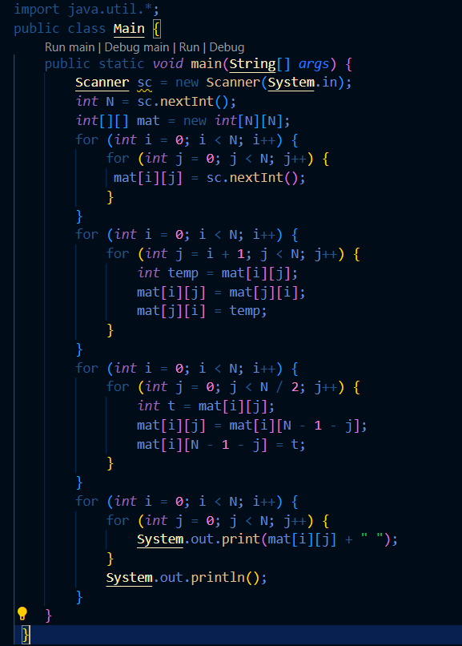

**Output-**

